**Brooklyn torah gazette**

**For parshas vayechi 5781**

Volume 5, Issue 18 (Whole Number 218) 18 Tevet 5781/ January 2, 2020

**Printed L’illuy nishmas Nechama bas R’ Noach, a”h**

For a free subscription, please forward your request to [***keren18@juno.com***](mailto:keren18@juno.com)

Past emails can be found on the website **ShabbosStories.com**

**Why I No Longer Need**

**My Holiday Tree**

**By**[**Sofya Sara Esther Tamarkin**](https://www.chabad.org/search/keyword_cdo/kid/23400/jewish/Tamarkin-Sofya-Sara-Esther.htm)

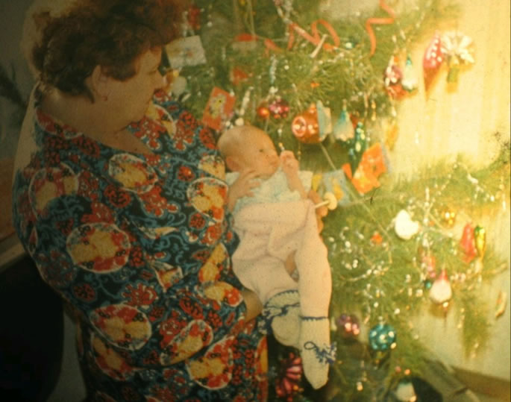

**My grandmother Zelda holding me as a newborn baby near the New Year's tree in 1976.**

As we approach the end of the calendar year, I am often asked, “Why do Soviet Jews buy evergreen trees for New Year’s?” The truth is that the reason for this tradition is intertwined with our Soviet upbringing.

I have many complex emotions about my childhood in the former Soviet Union. As I sort through the memories of oppression, anti-Semitism and suffocating propaganda, I try to focus on the positive aspects of my early experiences. Winters in Russia were overwhelmingly cold and long, but society adapted to the climate, and children in particular loved this time of the year.

The government built ice castles with slides and mazes in the main squares of major cities. I now see the magnificent lights hidden inside those translucent ice bricks as glimmers of hope and possibility for a better tomorrow.

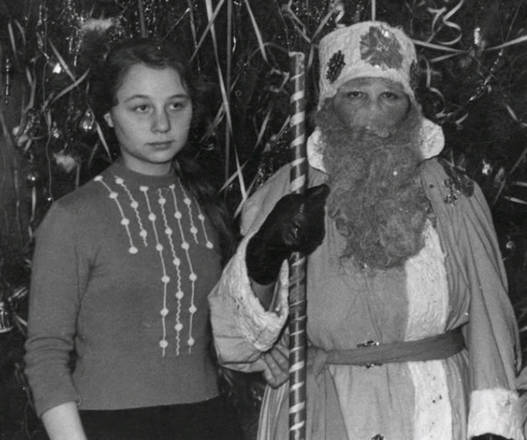

**My mom, near her mom (my grandmother Zelda), dressed as 'Ded Moroz' in a 1964 New Year's celebration.**

Soviet propaganda prohibited all religious holidays, allowing only two significant, non-Communist-related celebrations: birthdays and New Year’s Eve. The New Year’s celebrations often lasted for weeks as the Soviet citizens enjoyed drinking and partying.

Since religious observances of any kind were banned by the Soviet government, holiday symbols had to be secretly and strategically replaced and renamed. The Communist government erected enormous evergreen trees in the main squares of every city. These trees were renamed “New Year’s trees,” in order not to associate with their original source. The most prominent and recognizable character of the holiday was Grandpa Frost. Coincidentally, of course, Grandpa, named “Ded Moroz,” had a white beard and heavy winter coat with matching pants, and he gave out presents and delicacies such as chocolates and tangerines. Grandpa Frost had a granddaughter, “Snegurochka,” which roughly translates as “Snowwoman.”

**Two Adults in Every Family Secretly Dressed**

Two adults in every family secretly dressed as the famous pair and appeared a few minutes before the clock struck 12 to distribute gifts to the children. Every family erected a New Year’s tree in their small Soviet apartments, under which parents would carefully place gifts from Grandpa Frost and his granddaughter.

Simply put, these celebrations were the highlight of the Soviet childhood with the smell of the New Year’s tree eliciting joy and excitement.

My family immigrated to the United States in 1989, and I struggled to forge a new identity and to make sense of the newly found freedom. After I began my journey to connect to my Jewish heritage, I discovered enormous meaning behind our Jewish holidays and traditions. Like many Soviet Jews, however, I still found it extremely challenging to disconnect from familiar Soviet customs and symbols, despite my intellectual understanding of Soviet inadequacies. Even once we discovered that the “New Year’s trees” are symbols of an iconic December holiday, this knowledge somehow didn’t change our desire to be connected to the winter traditions.

**The Need to Find Heartwarming and**

**Relevant Meaning in Our Jewish Heritage**

Perhaps the only way to re-channel, refocus and transform our dedication to the practices of our childhood is to find heartwarming, relevant meaning in the eternal richness of our Jewish heritage. The new generation of children born long after the fall of the Communist regime can’t relate to our Soviet memories. Without judgment, I do believe that putting up a tree on Dec. 31 and decorating it with Jewish symbols creates identity confusion in our children. Perhaps instead of reinforcing old Soviet traditions with the new generation, we can teach them about our Jewish wisdom and sacred customs.

As people start to prepare for winter holidays, I reflect upon my first car-menorah parade in Philadelphia. I remember joining hundreds of people on an almost three-mile parade—starting at the John F. Kennedy Parkway near 22nd Street and ending at Independence National Historical Park—led by Chabad-Lubavitch of Greater Philadelphia. The parade ended with dancing, eating *sufganiyot* (doughnuts) and a giant menorah-lighting by Rabbi Abraham Shemtov, who, in 1974, was the first rabbi in the world to [light a public menorah](https://www.chabad.org/news/article_cdo/aid/2778619/jewish/How-the-Chanukah-Menorah-Made-Its-Way-to-the-Public-Sphere.htm), also in Philadelphia. I felt so proud having a menorah attached to the roof of my car. I felt like I had found my place in the world, as if that menorah infused me with clarity, connection and purpose. As the Lubavitcher Rebbe has taught, the best way to fight darkness is to shine a little bit of light.



Change can be complicated, unexpected and challenging. Memories are the same. On Dec. 31 of each year, I stay up to watch the ball drop, eat tangerines and remember the smell of the “New Year’s tree” of my childhood. Yet I no longer feel the need to celebrate this day by recreating those memories. My joy comes from lighting Friday-night candles, smelling the aroma of challah, dressing up for Purim carnivals, eating matzah at the Passover Seder and watching the glimmering lights of a menorah that commemorates the miracle of Chanukah.

It took 40 years to reach the Promised Land under the leadership of Moses, our greatest teacher. We can all appreciate the effort it takes to transition from our familiar reality and circumstances. So perhaps the next time you meet Soviet-born Jews who are looking forward to decorating a tree at the end of December, realize that they are simply trying to recreate their childhood experiences. Offer some heartwarming memories of your own celebrations, and invite them to experience the beauty of their Jewish heritage.

*Reprinted from the Parashat Vayigash 5781 email of Chabad.Org Magazine.*

**Rabbi Berel Wein on**

**Parshat Vayechi 5781**

At the end of the book of Bereshith, as we read in this week's Torah reading, there is little warning as to what the very next Torah reading will discuss and describe. The transition, from the benign and idyllic last years of the life of our father Jacob, is a harsh reality of servitude and slavery visited upon his descendants.

From the biblical narrative, it appears to have been sudden and unexpected. However, we already read in this week's concluding Torah reading of the first book of the Bible, that both Jacob and Joseph speak of redemption from the sojourn in the land of Egypt and a return to the land of Israel.

**A Warning that Jews Should View**

**Their Stay as Only a Temporary One**

From the nuances of their words and the hope and prayer that they expressed, it is obvious that they wish to warn the Jewish people that their future lay not in the land of Goshen or the flesh pots of Egypt but rather their stay in Egypt, no matter how many centuries long, should be viewed as only a temporary one.

In this, our forefathers indicated to us that this would be the pattern of Jewish history throughout the ages and that no matter how long the Jewish people would live in countries and areas outside of the land of Israel they should never view those societies as being permanent.

The remarkable thing about Jewish history is how repetitive it has been. If the Jewish presence in ancient Egypt was only for a few centuries, the presence of the Jews in areas such as Babylonia, Egypt, and Eastern Europe generally was for many more centuries than that of Egypt. We are all aware that all those societies came to an end, Jewishly speaking, as did ancient Egypt.

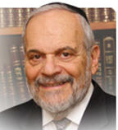

**Rabbi Berel Wein**

The last words of Jacob and Joseph were to the effect that the Lord would take the Jewish people from Egypt and return them to their ancient homeland, the land of Israel. It is this final message of the book of Bereshith that haunts them and follows the Jewish people throughout the biblical narrative of the remaining four books of the Torah.

Whenever troublesome challenges arose, regardless of the great miracles of survival the Jewish people were blessed with, there always was an element within the people that said it was preferable to return to Egypt rather than continue the struggle for Jewish identity and independence that only the land of Israel could guarantee to them.

Apparently, Jacob and Joseph were aware of this tendency towards weakness and assimilation within their descendants.

Their final message to all future generations of the Jewish people concentrated on the belief that the Lord would certainly redeem the Jewish people from all exiles, whether benign or cruel, and restore them to the challenge of independent nationhood in the land of Israel. That is why at the conclusion of this week's Torah reading we will repeat our ancient model and prayer to be strong and to strengthen ourselves and others for the tasks that always lie ahead.

*Reprinted from the Parshat Vayeishev 5756 edition of the L’Chaim Weekly, a publication of the Lubavitch Youth Organization.*

**The Difference Between Judah and Reuven**

**From the Talks of the Lubavitcher Rebbe**

**Rabbi Menachem Mendel Schneerson, Zt”l**

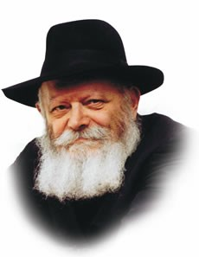

In this week's Torah portion, Vayechi, Jacob castigates his sons before his passing and takes away both priesthood and kingship from his firstborn, Reuven. The kingship is then given to Judah, as reward for two good deeds: his suggestion that Joseph be sold, thus preventing the brothers from killing him; his public confession about his sin with Tamar, thus saving her.

**An Insufficient Explanation**

This explanation, however, is insufficient, for at first glance it would appear that Reuven displayed the very same strength of character as his brother Judah, if not more.

Whereas Judah suggested that Joseph be sold for monetary gain, Reuven suggested that Joseph be thrown into a pit in order to return later and free Joseph. Furthermore, even when it came to admitting their transgressions, Reuven was on a higher level than Judah, as Judah only confessed in order to save the life of Tamar. Reuven, on the other hand, who is not even considered to have committed a true sin, was so penitent that for over a decade he was still fasting in sackcloth and ashes.

To understand, we need to recognize the difference between priesthood and kingship -- which Jacob took away from Reuven, and the birthright of the firstborn -- which Reuven retained.

**Kingship and Priesthood**

**Are to be in Service to Others**

Kingship and priesthood are primarily expressed in service to others.

A king administers the affairs of state; a priest bestows blessings and teaches Torah. Being a firstborn, however, is a matter which involves only the individual and has no bearing on one's relationship with others.

Thus, although Reuven tried to save his brother and immersed himself in a long period of penitence, the focus of his service was on achieving his own spiritual perfection rather than on helping other people.

In truth, it was because of his suggestion that Joseph was thrown into the pit full of snakes and scorpions. Even Reuven's penance was turned inward, for had he not been preoccupied with "sackcloth and ashes," perhaps he could have prevented Joseph from being sold and thereby precluded the entire Egyptian exile!

**The Worthiness of Judah**

Judah, by contrast, actually saved others through his actions, even though his own spiritual service may have been on a lower level. He saved Joseph from the pit and saved Tamar from death. It was this demonstration of self-sacrifice that proved to Jacob that Judah was the one who was worthy of kingship, for the essence of kingship is service to others.

From this we learn that a Jew must never concentrate on his own spiritual state to the detriment of his fellow Jew; love of one's fellow Jew must always be of prime importance. In this way, even if his own service is somewhat lacking, the merit of his love for his fellow Jew will connect him to the entire Torah and hasten the Final Redemption.

*Reprinted from the Parshat Vayechi 5756 edition of the L’Chaim Weekly, a publication of the Lubavitch Youth Organization. Adapted from Sefer HaSichot of the Rebbe, Vol. 15*

**Praying Like a Mentch**

**By Rabbi Moshe Meir Weiss**

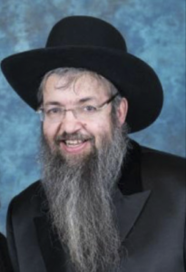

In the Kisvei Rebbe Yehuda Halevi we find a scary thought. He writes that sometimes Hashem will withhold someone’s livelihood or other needs in order to motivate him to reconnect with his Creator through tefilah. How scary a notion! Indeed, we find in today’s collapsing COVID-19 economy many people scurrying anew with feverish zeal to their Tehillim books and Siddurim begging Hashem to come to the rescue.

**Pray Before the Distress Falls Befalls Oneself**

How important is the Gemora in Sanhedrin, “L’olam yakdim adam tefilah l’tzorah — One should always pray before distress befalls him.” So too we find that when suffering befell Iyov, his colleagues asked him, “Haya aroch shuacha shelo batzor — Did you arrange your prayers before your travail?” In a similar vein, the Gemora in Masechtas Shabbos tells us the important directive, “L’olam yispallel adam shelo yechele — A person should always pray not to become sick.” As the commentators teach us, it is much easier to thwart the decree before it happens than after the hammer strikes.

Thus we find that a very important discipline of tefilah is to pray in anticipation rather than in reaction. This is what the well-known posuk says in Asheri, “Karov Hashem l’chal kor’ov, l’chol asher yikrauhu ve-emes — Hashem is close to all those that call to Him, namely to all those who call to Him in truth.” Note the emphasis: those that call in truth, rather than in need.

We are charged to pray to Hashem before we are propelled to do so. We therefore can understand the famous verse, “Ashrei adam m’facheid tomid – Fortunate is the one who is always fearful.” We cannot interpret this to be referring to the worrywart for the Gemora tells us that worry breaks the very spirit of Man. Rather, the verse is lauding the virtues of one who is ever mindful of dangers that can happen and constantly prays for Divine protection.

**The Need to Pray for the Safety of our Children**

Thus, when we hear of school bus tragedies, it reminds us to pray for the safety of our children. When we hear of someone suffering from coronavirus or dreaded diseases, it prompts us to pray for a healthy body. When we see flashing lights on the highway, it should jolt us to pray for safe travel.

When we see the frightening number of unmarried singles before us, we should pray at an early stage that our children find their destined mate easily, and that when the do get married, they should live in harmony, conceive and have children. With the baby-boomer generation rapidly approaching retirement, we should pray that we age gracefully and not need to become a burden on our children and grandchildren.

Suffice it to say, that with proper anticipatory training, our tefilahs should be able to take on enough of a variety that we should be able to successfully avoid the great pitfall of our tefilos becoming repetitive and a boring routine.

It behooves us to remember Reb Yehuda Halevi’s urgent dynamic, that if we ignore Hashem and fail to connect with Him through the gift of prayer, He might, chas v’shalom, lo aleinu, motivate us by withholding something from us that is important and dear to us. Therefore it is incumbent upon us to self-motivate in this all-important life’s arena.

**A Wonderful Tool to Aid Us in Better Prayer**

I would like to share with you a wonderful tool we have just been blessed with to aid us in better prayer. ArtScroll has a superb sefer by Rav Schwab, zt”l, on proper prayer. It is a ‘must read’ for every serious student of proper tefilah. Rav Schwab relates the well-known Talmudic dictum that our tefilahs were enacted to correspond to the korbanos. And, just like the root of the word korban/sacrifice is k’rov, which means to come close, so too the aim our prayer is to come close to Hashem.

Carrying the analogy one step further, Rav Schwab says that there are three steps in the bringing of a korban: Hefshet, flaying the animal of its skin; Nituach, dissecting it into its many separate limbs; and finally v’kalil la’ishim, consigning it to the fire. In a similar vein, Rav Schwab says, we find these steps by our prayer as well.

The flaying is when we strip ourselves of our worldly thoughts as we get ready to talk to Hashem. Thus, in preparation for tefilah, we block out thoughts of clients and carpools, dinner and fashions, vacations and recreation. The dissecting part is accomplished when we work to humble ourselves and cut ourselves down to size in preparation to approach our Maker.

**The Proper Approach to Prayer**

For, as we are taught, the proper approach to prayer is to envision ourselves as an, “Oni ha-omeid al ha-pesach — A pauper standing by the door asking for mercy.” As the posuk tells us, “Lev nishbar v’nitke Elokim lo sivze — A heart that is broken and crushed Hashem does not despise.” Finally, Rav Schwab concludes that the analogy to consigning the sacrifice to the fire is when we pray with fiery passion.

I once heard from a Mr. Lowinger in the name of his father that since every sacrifice is accompanied with salt, where is the salt in our prayers? He answered beautifully that if we accompany our prayer with some tears, we even include salt in our tefilos since the tears contain salt.

Once again, in the merit of our efforts in the arena of prayer, may Hashem fulfill all of our wishes.

*Reprinted from the November 30, 2020 email of The JEWISH VUES.*

**Thoughts that Count**

**For Parashat Vayechi**

*And Israel strengthened himself and sat up in bed* (Gen. 48:2)

From where did Jacob derive this extra strength?

The Talmud explains that when someone visits a sick person, one- sixtieth of the illness is taken away if the visitor is his "astrological twin."

According to our Sages, Joseph resembled his father in many ways. Thus, when he visited him, a sixtieth of his father's illness was removed and he was able to sit up in bed. This is alluded to in the Hebrew word for bed, "mita," the numerical value of which is 59.

*Reprinted from the Parshat Vayechi 5756 edition of the L’Chaim Weekly, a publication of the Lubavitch Youth Organization.*

**Parshas Vayechi**

**Gedolim Had it Easy**

**By Rabbi Bentzion Shafier**

**Founder of TheSmuz.com**



“*And Yaakov lived in the land of Egypt seventeen years; and the days of Yaakov — the years of his life — were one hundred and forty-seven years*.” — Bereishis 47:28

The Ba’al HaTurim explains that the gematria (numerical value) of the word vayechi (lived) is seventeen. The Torah is telling us that Vayechi — the life of Yaakov was seventeen years. Up until that point, he had suffered so much that his years couldn’t rightfully be called a life. The sum total of the years that he spent without torment was the seventeen years that he lived in Mitzrayim. That was his life.

With this, the Ba’al HaTurim gives us a perspective on the life of Yaakov: he had a rough existence. For the first sixty-three years of his life, he suffered at the hands of his twin brother Esav. From the time that they were in the womb together, they fought about this world and the World to Come. That period ended when he ran for his life because Esav was plotting his murder. Yaakov then spent the next fourteen years hiding out as a fugitive in Yeshivas Shem v’Ever.

When it was time to marry, he found himself in the home of Lavan, “the devious one.” For the next twenty years, Yaakov was an unwelcome intruder in a culture alien to his nature, eating at the table of a father-in-law who attempted in any way possible to swindle and cheat him. That period came to an end when Lavan chased him down. Once again, he escaped as a fugitive. Immediately after that, he met up with Esav, who had set out with four hundred men to kill him. Barely escaping with his life, he settled in Eretz Yisrael, only to have the tragedy of Dina’s kidnapping befall him.

**Living in a State of Mourning**

After this, his most beloved and precious son, Yosef, was stolen from him. And for the next twenty-two years, he lived in a state of mourning, not sure if Yosef was alive or dead. Finally at the age of 130, he settled in Mitzrayim, where he enjoyed seventeen years of peace.

The Ba’al HaTurim is telling us that the Torah uses the expression, “And Yaakov lived in the land of Egypt seventeen years,” to teach us this point. He suffered so acutely during the earlier part of his life that it couldn’t be called living. This was the first time that Yaakov lived peacefully, without affliction.

This concept becomes difficult to understand when we focus on who Yaakov Avinu was. Chazal tell us that Yaakov was the greatest of the Avos. He was born with a father and grandfather who were his rebbeim. From the time of his earliest youth, he spent his days in the tent of Torah, completely immersed in the sea of learning. Surely he didn’t need a difficult life. Surely he could enjoy this world and not become distracted by the glitz and the glitter. So why did he need to suffer?

The answer to this question can be understood with a mashal.

**The Gym and the Spa**

Picture a very exclusive health club with two separate sections. On the left is the spa, and on the right is the gym. The spa is where people relax. Whether sitting in the steam room, lying in the Jacuzzi, or lounging in the sauna, the mode of activity is to loosen up and enjoy. The gym is where people exercise. They push themselves, they strain, and they challenge their bodies.

Imagine that the first time you visit this health club, you decide to go straight to the spa. By mistake, instead of turning left, you turn right and find yourself in the gym. You look around, and all you see are red-faced men lifting heavy loads, grunting, groaning, and sweating away. The first thought that comes to your mind is, “What kind of lousy spa is this? What is all of this straining? The red faces? The grunting and groaning? I thought people are supposed to be lying around, chilling out, enjoying?”

This is an apt parable for life. When HASHEM made man, He created two worlds — this world and the World to Come. Each has its plan. Each has its purpose. This world is the place of growth. The World to Come is the place that we enjoy that which we accomplished.

**Our Mission is to Go Through the Challenges of Life**

We are put into this world so that we can go through all the challenges of life: resisting temptations, choosing that which is right, and thereby shaping ourselves into who we will be for eternity. We were put into this world to grow. This world is the gym. The World to Come is the spa. It is the place where we will enjoy the fruits of the work that we put in while in this world. It is the place of reward.

The reason that many people have difficulty understanding life is because they confuse this world for the World to Come. As a result, they have many, many questions. Why does man have to work so hard? Why are there so many challenges? Why is there suffering in the world?

Once a person clearly understands the purpose of life, many of his questions naturally fall away. But until a person adopts an Olam HaBa approach to life, nothing makes sense — not work, not challenges, and surely not pain and suffering.

If you ask a person who regularly works out if he enjoys the training, the answer will be a resounding “Yes!” But it is work. It is focused and often difficult. To grow one must strain. No pain, no gain. On the whole, the activity may be enjoyable, but it often isn’t easy.

HASHEM created us to use this world for its intended purpose — to grow. Should life be fun? The answer is yes. But it is focused. It has a plan and a purpose.

**Gedolim Didn’t Have it Easy**

We often take the attitude that gedolim had it easy. Sure to be Avraham Avinu, that would be a cinch. After all, HASHEM spoke directly to him. He knew where he was headed in life. For him, life was a walk in the park. But me, I suffer. I have it rough.

The reality is that every human suffers. That is a part of life. But it’s not by accident, and it’s not because HASHEM isn’t clever enough to figure out a way to create man without pain and suffering. Quite the opposite, these situations were hand-crafted as part of the challenges that man needs to grow.

This life is the great laboratory of growth. When a person understands this perspective, life itself has meaning and significance. He will understand both the purpose of his existence and the reason for his life settings. With this vantage point, he can truly enjoy his stay on the planet, knowing the meaning and depth behind everything that he lives through.

*Reprinted from the website of Theshmuz.com.*

**Non-Jewish Video Maker Films**

**Upbeat Features on Hasidim**

**By Daniel Keren**



**Peter Santenello interviewing Rockland County Chaverim volunteer**

I recently visited the homepage of Aish.com and my attention was directed to a video on Chasiddim made by Peter Santenello, a non-Jewish video maker who apparently enjoys visiting “exotic” communities around the world and trying to learn how the members of those communities think about themselves and see the “outside” world.

Many of these Santenello videos have been posted on youtube recently and perhaps not surprisingly have been racking up very impressive views, although it is not possible to determine what percentage of those viewers are Jewish or non-Jews.

One of those fascinating videos was a 19 minute 41 second view of life and the activities of the Rockland County Chaverim volunteers titled “How These Hasidic Jews Can Save Your Life” (youtube), which at the time of my writing this review had generated since December 6th an impressive 237,000 views around the world.

Peter appeared greatly impressed that the Chaverim volunteers operate 24/7/365 and absolutely do not charge for their chesed (kindness) services of mercy. He was also impressed that the volunteers are not paid for their services. Chaverim is the Hebrew word for “friends.”

**Videos Demonstrate a Great Kiddush Hashem**

And a great Kiddush Hashem was their telling Santenello that during a week-long power outage in Rockland County, Chaverim drove around throughout the day to homes of elderly patients who were on life support and provided life-saving generators to hook up their life-support equipment, thus negating the need to transport them to uncomfortable hospitals. The volunteers kept track and returned to the home to recharge the generators each day.

Another recent mitzvah of the Chaverim volunteers occurred with an autistic child managed to at 2:45 A.M. unlock one of the doors. The distraught mother could only relate that her son was wearing red pajamas and yellow crocs. Baruch Hashem, the Chaverim crew who woke up in the middle of the night managed to locate the child within minutes of beginning of their search.

Peter was also greatly impressed that Chaverim of Rockland County do not discriminate, and eagerly offer their free services to even non-Jews. The organization even have six non-Jewish volunteers who offer their services on Shabbos. Last year, the volunteers responded to more than 32,000 calls for assistance. As one of the Chaverim told Mr. Santenello, “We enjoy every minute of life.”

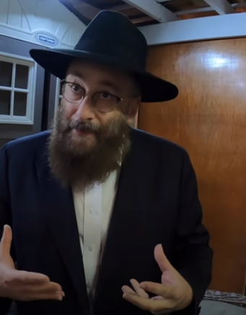

**Rabbi “Naftali” of Crown Heights**

Another penetrating Santenello video you might want to view on youtube is “Hasidic Jews’ View on Intimate Relationships & Modern Culture – NYC” that since being posted on November 8th has generated 700,000 plus clicks by viewers.

Peter is introduced to Rabbi “Naftali” who shows him his special Shabbos room where family members and guests get together every seventh day to celebrate the most important and beautiful day of their lives. Naftali explains just how Shabbos gives meaning to the rest of the week and how on this day all talk of mundane topics is avoided.

As the title of the video suggests, Mr. Santenello asks question about those two weeks in the month when married couples are not intimate with each other and Naftali explains how very important that separation is to the vitality of the Jewish marriage.

Two other recent videos posted by Peter that are perhaps more appropriate for female viewers are his 38 minute interview with Malky, a resident of Boro Park titled “What Hasidic Women Have to Say” and a shorter 17 minute version titled “Lifestyle of a Hasidic Woman.”

In these two videos, Malky shows Peter around the community and emphasizes that she doesn’t see the need to do things that compete with men, as the nurturing functions of a Jewish woman as both mother and wife are important enough. Both of these recently posted videos have already generated more than 300,000 views, indicating that there is a great interest for true interviews with the “exotic” Chassidim that are done in a respectful and not condescending manner.

All four of these professionally done videos can be accessed by clicking the titles and adding – “youtube.”

*Reprinted from the January 1, 2021 edition of The Jewish Connection.*

**Rabbi Shimshon David Pincus, Zt”l, on Praying to G-d**

*The following letter was written by R’ Shimshon David Pincus z”tl (1945-2001; rabbi of Ofakim, Israel) in response to someone who complained that his prayers were not being answered and he had therefore lost the urge to pray.*

I received your letter, thank you. You asked: What is the precise application of the teaching, “Whoever prays for his friend is answered first”? I don’t think there is a way to explain it precisely, other than to take the words at face value. Regarding your specific problem, I don’t know what advice to give. This is because prayer is “service of the heart,” and the heart is very personal. How is it possible to give advice when no two hearts are the same?

Nevertheless, I will try to dissect the problem.

The problem is that we view prayer as a wonderful “spiritual” experience. I am not saying that this is wrong; sometimes it is so. But, besides this, there is something more fundamental and wonderful– prayer is a chance to speak to G-d. It’s as simple as that.

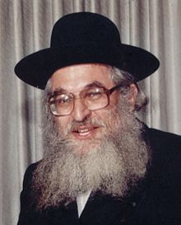

*Rabbi Shimshon David Pincus, zt”l*

It all begins with Emunah / faith. Emunah means knowledge of the simple fact that there is a G-d. Just like there are tables and chairs, there is a G-d. I don’t say that you should know this because it is a lofty level or, conversely, because one who doesn’t know it is lowly or a heretic or anything else. It’s just a fact. And, since He exists, it’s possible to talk to Him, even without having a spiritual experience.

When you wrote me a letter, was that a spiritual experience? Not at all! Rather, it’s a fact that there’s a man in Ofakim named “Pincus.” It’s also a fact that that man [referring to himself] wrote a book about prayer. And, it’s a fact that there is a postal service. Therefore, it’s possible to write to him; maybe he can help.

In the same way, it’s a fact that there’s a G-d; that He hears everything; that He created everything; that He is extremely pleasant to deal with; and that He cares about me and is concerned about my welfare even more than I am. Therefore, it is possible to turn to Him, whether one feels it in his heart or his mind, or feels nothing at all. A fact is a fact, reality is reality, and that’s all!

And yet, granted that it’s possible to speak to Him, but sometimes, G-d forbid, a person does not feel like he wants to speak to Him. At such times, one must turn to the reality that was just mentioned. One does not cut off his nose to spite his face; certainly, one will not throw away his life out of spite. . . . In short, make peace with G-d.

Though He is very great–capable, for example, of making a camera, the human eye, with an incredible number of parts–nevertheless, He does not hold a grudge. Rather, He is waiting longingly and with open arms for your return. . .I add my own blessing of a simple person that G-d will fulfill your desires in the best way. Shimshon David Pincus (Nefesh Shimshon: Igrot U’Ma’amarim p.44. - Hamaayan)

*Reprinted from the Parashat Vayechi 5781 email of whY I Matter, the parsha sheet of the Young Israel of Midwood (Brooklyn) edited by Yedidye Hirtenfeld.*

**More Thoughts that Count**

**For Parashat Vayechi**

*Gather yourselves together that I may tell you what will befall you in the end of days* (Gen. 49:1)

As Rashi explains, Jacob wished to tell his children when Moshiach would arrive, but "the Divine Presence departed" and he was thus unable to do so. But why was it necessary to take away the Divine Presence? Why didn't G-d just tell him that he was forbidden to reveal this information?

What happened, however, was that Jacob foresaw all the suffering his children would be forced to endure throughout the exile, and became saddened. As "the Divine Presence only rests on a joyful person," it departed as a natural consequence of his mood. *(Rabbi Chanoch Tzvi of Bendin)*

*The scepter shall not depart from Judah... until Shiloh comes* (Gen. 49:10)

"Shiloh" is the numerical equivalent of "Moses" (345); "until Shiloh comes" is the equivalent of "Moshiach" (358). *(Zohar and Baal HaTurim)*

*Reprinted from the Parshat Vayechi 5756 edition of the L’Chaim Weekly, a publication of the Lubavitch Youth Organization.*